**ATAR Human Biology Unit 4**

**EXTENDED RESPONSE 4: VALIDATION TEST - EVIDENCE OF EVOLUTION**

**Validation Test: _______ / 40**

**Total % _______**

**Read the text below and answer the following questions.**

Digging for dinosaur bones is a popular 'holiday' activity for adventurous visitors to outback Queensland. They're searching for large dinosaurs called sauropods.

These were land based dinosaurs and they roamed the vast forested floodplains that surrounded the inland sea that covered much of Queensland and central Australia about 95 million years ago.

Well-preserved bones and other fossilized remains of these dinosaurs have been found in the rocks underlying the Mitchell grass downs that now dominate the landscape around the town of Winton.  
This includes the remains of the largest dinosaur yet found in Australia - an animal that has been nicknamed 'Elliot'. These bones were first discovered in 1999 by local grazier David Elliott, he noticed a bone fragment on the surface of the ground as he was mustering sheep.

Scott Hocknull from the Queensland Museum says "it wasn't just any old fragment of bone that you find on the surface - this was a piece of thigh bone that measured 50cm in diameter, so you're talking about an animal with a 50cm wide knee".

Mr Hocknull describes the dimensions of this dinosaur (it was) "an animal with a four metre high rump, maybe 16 metres long and 20 tonnes in weight". "it wasn't just any old fragment of bone that you find on the surface..."The Queensland Museum has led a number of 'digs' at the Elliot site near Winton, involving the Elliott family and volunteers

1. Who am I? [1]

2. Describe me. [1]

3. a. When did I live? [1]

b. How did I die? [2]

4. How was I fossilised? [3]

5. Describe the climate and vegetation at the time I was alive. [1]

6. What events had to occur for me to be discovered? [2]

7. What can we learn from this discovery? [2]

8. Relative dating gives: [2]

9. Absolute dating gives: [2]

10. What are the problems associated with relative dating? [4]

11. What are the problems associated with radiocarbon dating? [3]

12. Describe an example of an index fossil. [2]

13. What is a half-life? [2]

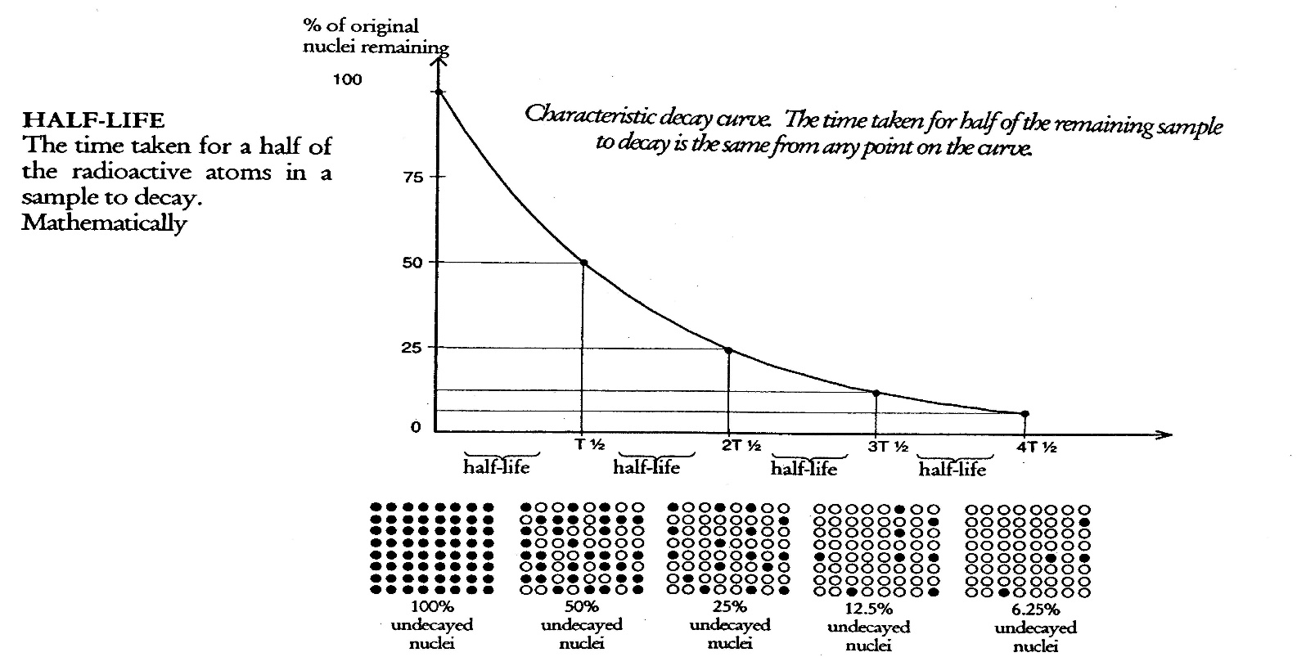14. Examine the graph below and answer the following questions.

a. How many half-lives does it take to reduce the percentage of original nuclei to 25%? [1]

b. If this represented a radioactive isotope with a half-life of 1300 million years, what is the age of the sample with 12.5% of the original nuclei left? [1]

15. Examine the graph below and answer the following questions.

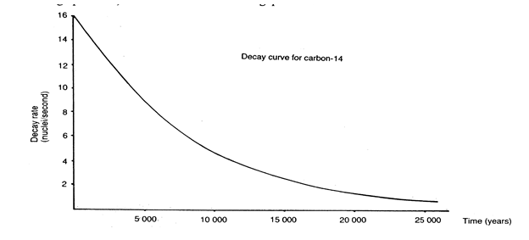

a. Calculate the age of a fossil that has a decay rate of 6 nuclei/second. [1]

b. Assuming that the half-life of Carbon-14 is 5730 years, approximately how many half-lives have passed? [1]

c. Which of the following could be dated with this method and why? [2]

i) An Australopithecine skull (4 million years old)

ii) A stone axe

iii) a Cro-Magnon skull (40 000 years old)

iv) A bone found in a layer above one dated at 60 000 years

v) A bone found in a layer below on dated at 100 000 years

16. Examine the picture below and answer the following questions.

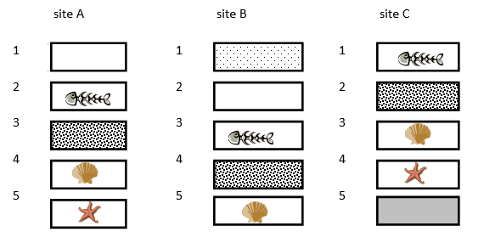

a. Which strata is the oldest of all sites? [1]

b. Which strata is the youngest of all sites? [1]

c. Which site gives the best representation of the oldest fossils and why? [2]

d. Naming the strata, which fossil is present in all three sites? What can you infer from this? [2]